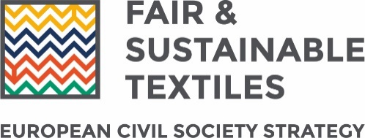
Press Release

Brussels, 3rd June 2020
MEPs call on the Commission to follow civil society approach in textile strategy
Today a group of 53 Members of the European Parliament (MEP) from across the political spectrum have written a letter to Commissioner Sinkevičius, Hogan, Reynders, and Urpilainen endorsing civil society’s approach to rethinking the global textile value chain. In their letter, MEPs stress the “need to adopt a truly comprehensive approach that deals with the various issues highlighted in [the] civil society strategy, including human rights, environment, governance, and gender”.
Following the announcement of a new ‘comprehensive strategy for textiles’ by the European Commission, in April a collective of 70 civil society organisations proposed their own non-official ‘shadow strategy' outlining the measures that the EU could take to contribute to fairer and more sustainable global Textile, Garments, Leather and Footwear (TGLF) sector. In today’s letter, MEPs “warmly welcome this civil society proposal” and “invite [the Commission] to follow the approach of this civil society proposal in the development of the comprehensive EU textile strategy”
The TGLF sector has long been characterised by labour rights and human rights abuses along with the immense pressure it exerts on our environment and climate. The civil society shadow strategy proposed a unified and comprehensive approach to tackling the various problems associated with the TGLF sector.
The civil society vision for a comprehensive EU Textile Strategy contains recommendations including:
- Ensure companies are legally obligated to take responsibility for not only their own activities but their whole supply chain by applying an EU due diligence law across all sectors, including specific requirements for the TGLF sector. Signing a multi-stakeholder partnership should not exempt business from responsibility.
- Stricter environmental rules that cover how textile products sold in the EU are designed and produced, legal and financial responsibility on producers for when their products become waste, as well as meaningful measures to promote transparency.
- Ensuring brands and retailers are legally obliged to honour contracts and end the culture of unfair purchasing practices that gives them impunity to cancel orders without honouring payments - leaving workers without pay and a wasteful pile up of unsellable products.
- Make governance reforms and better law enforcement in producing countries part of the solution to sustainability issues faced in the TGLF value chains.
- Through trade policy, use EU market power to leverage sustainable production practices in the TGLF industry.

